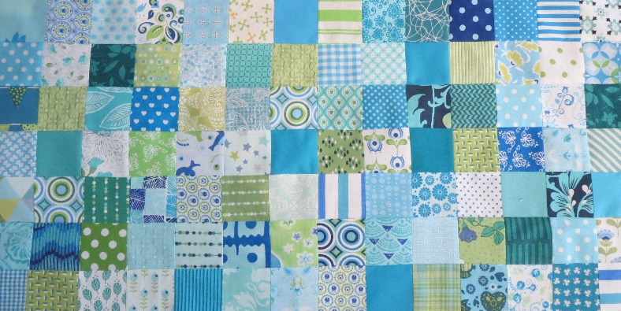
Groene Quilters
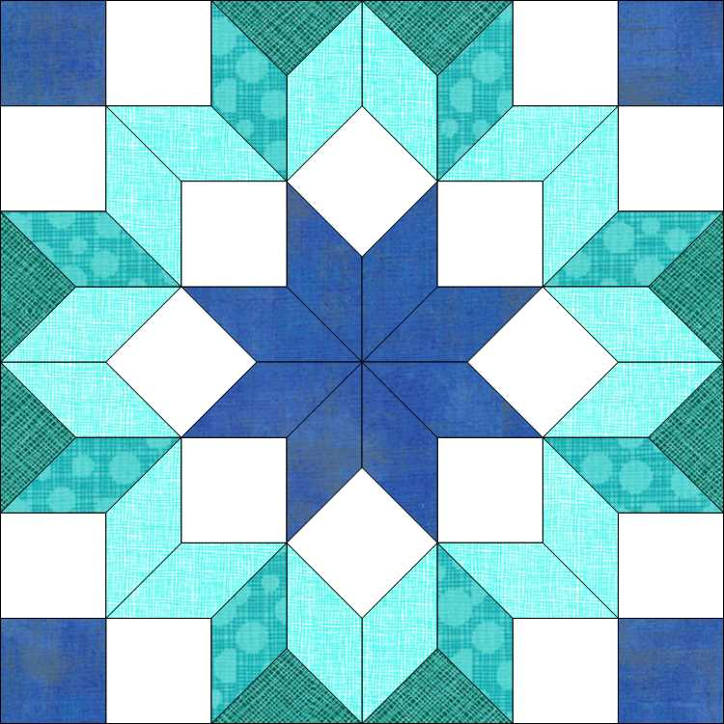
JULY 2023
Block 8 Carpenter's Wheel block, EPP, English paper piecing.
Block is 10.5 by 10.5 inches including 1/4 inch seem allowance.

What it you need:
- Background fabric and various fabrics for the flower.
- The templates for the block.
- Rotary cutter, ruler, scissors
- Needle and thread, pins.
- Glue for EPP

There are 3 sheets of templates. Block 8 July templates, are the templates with the seem allowance. So you can make this traditional or with EPP. You can use the templates with the seem allowance to cut the size of the fabrics. Block 8 EPP part 1 and Part 2 are the EPP templates. I always print EPP on 120 grams paper, which is a nice strength to use. Most convenient is to first sew all the fabric around the cardboard and then assemble it. Instead of sewing around the cardboards, you can also use the gluing technique.

Start with the star in the middle. Put all the diamonds together. Then the squares, sew them in the right place against the star. Then you continue with the diamonds. Here it is most convenient if you sew three diamonds together and then sew them against the squares. Then you fix all the squares in the corner and you end up with the triangles.

Flatten everything. You can remove the inner cardboards, but leave the outer edge for a while for strength.

Here again some YouTube videos.

English paper piecing with Belinda
H
https://youtu.be/XMlZOH6JDoQ
Life under Quilts
https://youtu.be/3W8OJ96bBU8
Lucy Boston Patchwork, of the crosses part 2
https://youtu.be/yo_Ufe7g0Xs
Coco & Theodore, English Paper Piecing, All about glue
https://youtu.be/_KAmMlCoPy4

