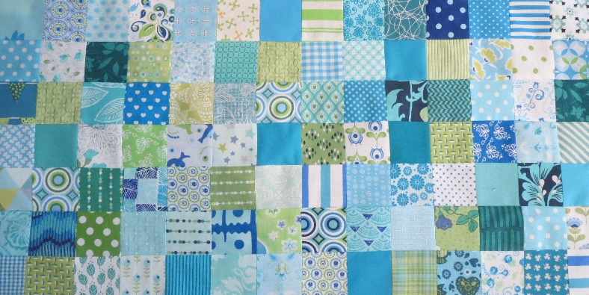
AUGUST 2023
Block 9 Twisted Log Cabin, Traditional or FPP Block is 10.5 by 10.5 inches including 1/4 inch seem allowance.
What do you need:
- Background fabric and various fabrics for the flower.
- The templates for the block.
- Ruler, ad a 1/4 inch ruler, scissors.
- Needle and thread, pins or sewing machine.
- Iron.
- Lightbox.
- Fun-dation paper or anything else you make FPP on. For the 7 inch version print you need 1 sheet. The 10 inch version if you draw it yourself on paper or you don't mind printing 2 sheets.

The traditional way:
You work from the square "G" . Copy the templates to the fabric. You can give each template a different fabric or you can make rounds of 4 of the same fabrics. Put the 4 small triangles on the square. Then the elongated triangles. Each round 4 pieces. The whole thing is 10 inches in size when finished.

The FPP way:
If you do the FPP way then you can choose to make the Log Cabin full size or smaller with a border around it to make it 10 inch. I chose the 7 inch, easy because that is only 1 sheet through the printer. Some people prefer to draw themselves, then you can use the 10 inch template. There is a red dotted line ( on both papers) where you put the two pieces together. You can also work with 2 sheets that you print. Then you have to stick the second sheet with a glue marker against the other as soon as you start with a triangle that overlaps.

Note! Make sure your fpp paper is always with the right side up, so the readable side!
A light box or a good lamp will help you see if the pieces of fabric are large enough!

You tube if you need some help!

Amanda Rolfe, Foundation paper pieced the wonky log cabin block
https://www.youtube.com/watch?v=Du5004My3mk

Riley Black Design, FPP a Log Cabin Block with Christopher Thompson
https://www.youtube.com/watch?v=M2NSM0tE6yk

