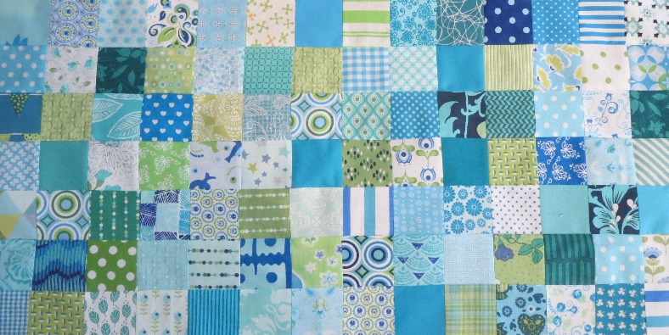
Groene Quilters
MARCH 2023
Block 4 Card trick. Block is 10.5 by 10.5 inch including surcharge of 1/4 inch.
What you need:
• Background fabric and four different fabrics for the square.
• PDF with the templates.
• Cutting knife, ruler and mat, scissors, frixion pen or pencil.
• Needle and thread, pins.

It's a much chosen block in a quilt, fun to do. You can do 2 things. You work with the template of the triangles. Or you work with squares that you cut in half. Both options are explained.

Option 1:
• 4 different fabrics for the squares and a back raw material. You need 4 large triangles of the background material (template A). In addition, you have to cut 2 large triangles of all four fabrics Template A), a total of 8. Of the small squares (template B) you need 4 triangles of the background fabric and 2 triangles of each square.
• Cut out your template and draw it over to the back of the fabric. You can use a frixion pen. Cut all drawn fabrics to size.
• Put the large triangles together according to drawing. Sewing the right side in with a 1.4 inch seam allowance. Then make the small triangles. Draw the template over and cut out. First, sew the small triangles together. Iron and then place it on a large triangle. Good sides against each other and sew together. Iron. Note the middle square consists only of 4 small triangles. Sew 2 times 2 triangles together, iron and then make it in to a square. Put everything in the right order and sew everything together per row, iron. Sewing the rows together and iron the end result.

https://www.youtube.com/watch?v=1IZ3x5djg1Q

https://www.youtube.com/watch?v=u8L1NeZN9r8

Option 2:
Cut two squares of background fabric and cut it in half. Cut 4 squares of each fabric (except the background fabric) 1 square, and cut it in half. Cut 2 small squares and cut them in half. And of every other fabric (except the background) 1 square and cut it in half. Now you can start putting everything together. Explanation see above.

https://www.youtube.com/watch?v=SWN3ijnLYvs

