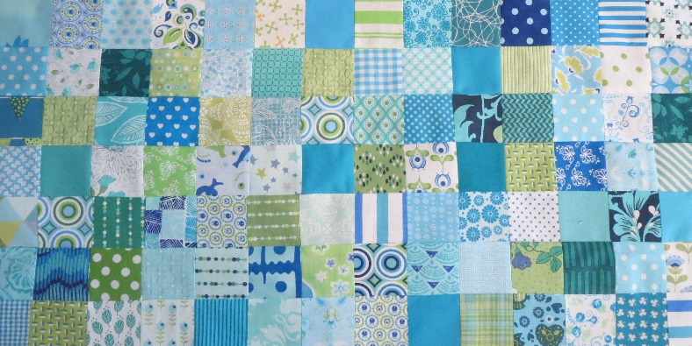
Groene Quilters
NOVEMBER 2023
Block 12 MOLA/KUNA flower block. Block is 10.5 by 10.5 inches including 1/4 inch seam allowance.

What it you need:
- Background fabric and different fabrics for the flower.
- The template for the block.
- Scissors, small scissors.
- Needle and basting thread, pins
- Thin needle or applique needle with matching thread.

Block 12 can also be called reverse applique, but the more layers you apply in this way, the more you can actually speak of Mola or Kuna.

Look at the YouTube video, where the explanation is clearest. Better than I can describe.

You will need different fabrics of about the same size. The bottom square should be larger than the flower. Cut the flower out of the paper. Place two pieces of fabric top of each other, place the flour on top. Pin this to the fabric. Sew in the top layer, around the outside of the flour. Remove the paper. Indicate the circle of the flower. The paper circle is larger than the heart of the flower. Sew around the heart and finish the leaves as well. See video. Once you've done all this, remove the paper circle and then comes the fun part.

Cut away the fabric. Use a pencil or a chalk marker and draw where it needs to be cut away. Draw about 1 cm from the row edge. If you are already proficient in this, it can be a bit narrower. Remember, only cut off the top layer! Once you have cut it out, you will have to make small cuts to be able to fold the shape inwards, you do this a little before half of the fold.

Fold the edge inwards against the basting thread, use your needle to fold the fabric inwards and secure with small stitches. Which this at all the petals and the heart of the flower. Take another piece of fabric and place it right side down on the back of your work. Pay close attention to see if it covers the entire flower. Thread the fabric onto your workpiece on the outer edge. Turn your workpiece over. Draw the line on the sheet again with a pencil and cut away the fabric. Please note, only the top layer! Cut again a little before half of the fold and sew again. Make an extra circle in the heart of the flower. So put your fourth fabric right side against the back. It should cover the circle. Secure with some basting stitches. Turn the workpiece to the right side. Draw a circle again with a pencil, don't make the hem too narrow. Cut away the fabric. Make small cuts and push the fabric back in and sew.

This first YouTube tutorial is in Dutch, but if you look closely you’ll understand what she does.

Draadje Los, Joke Schuurman https://youtu.be/yZ7UECfDP_k
Su3Daely Design https://www.youtube.com/watch?v=vxIz21n_PHQ&t=11s
Justhands-on tv. Revers Hand Applique With Dawn Cameron-Dick https://www.youtube.com/watch?v=hWJLLV1YL_U

