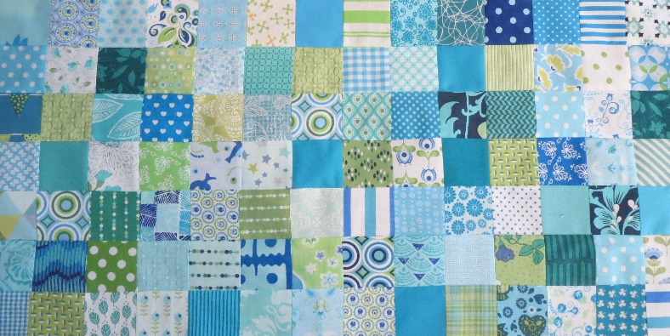
APRIL 2023
Block 5 Heart block FPP, foundation paper piecing. The block is 10,5 by 10,5 inch with seam allowance.

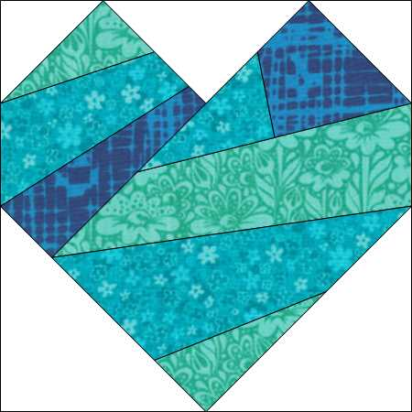

What you need:
- Background dust and various substances for the heart.
- A sheet of fun-dation (or another brand of foundation paper) to print the pattern
You also can use tea bag paper and trace the trace the pattern.
- Rotary cutter , ruler, an FPP ruler with a 1/4 inch ledge. Something that is thin and hard to make the fold. This is already possible with an old customer card.
- Scissors, needle and thread, pins.

FPP is actually the counterpart of EPP, English paper piecing. With FPP you can work very accurately and you can make many complicated patterns very easily. And so handy for using scraps!
The beginning is actually the hardest part.
Where you should pay particular attention to is that the sheet with the text is above and not in mirror image. Believe me, that's happened to me a few times!

Follow the numbers on the drawing. You sew the fabrics on the back of the drawing. Make sure that the pieces with allowance are larger than the block.
In the first step you have to put two pieces of fabric with the right sides on top of each other and that has to be on the back of the fpp-paper. The block for A1 is easy, you can see if it is bigger then the block with enough seam allowance. The second pieces, you always have to fold back, to see if it fits. Does it fit, then you sew with a stitch length of 1.0 / 1.5 on the paper.

The whole block consists of 3 parts that you put together and then finish to get a square. The pattern of block 5.1 finished at 7 inches, because otherwise it will not fit on a sheet when you print. To finish at 10,5 inch, you just haven to make a border around it.

If you want to draw it on paper, you can choose the pfd block 5.2. That will finish completed 10,5 inch.

There are a lot of tutorials about fpp. So have a look!

FPP part 1: https://www.youtube.com/watch?v=onmfFXyW7bY
FPP part 2: https://www.youtube.com/watch?v=KVKLA...
Another YouTube tutorial: https://youtu.be/t7Kx4Q7JSwQ

If you want to piece this block the traditional way, choose the pdf with block 5.3.
The templates create a block of 10, 5 inch..

