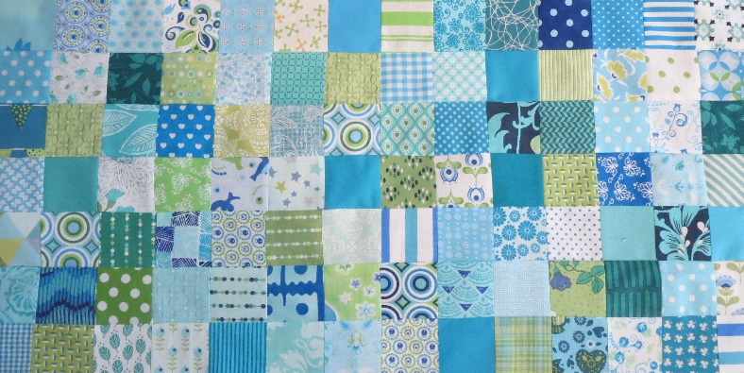
Groene Quilters
OCTOBER 2023 Block 11
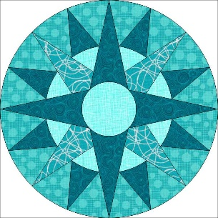
Mariners Compass Block is 10.5 by 10.5 inches including 1/4 inch surcharge.

What it you need:
- 6 different fabrics if you want to give all templates their own color.
- Rotary cutter, ruler, scissors
- For fpp 2 sheets to print on.
- Needle and thread, pins.

You can create this block in two ways. The traditional way with the parts you sew together or you use the fpp method.

The traditional way.
Cut 8 x Z and 8 x H and sew them together. Flatten them and then cut the pieces J to Y. Put them on the 8 pieces on both sides. Cut G and put it between the 2 blocks you already have. Spread. Then you have 4 quarters when you're done. Cut E and F and put it all together. Spread. Cut the circle and sew it onto it. Then cut the four corner pieces, put them together and secure the middle piece with needles and sew. Iron the whole thing.

The FPP way.
Print the PDF twice on fpp paper. Each quarter consists of 2 parts. Make it 4 times. Then put The big points A and B 2 times in between. Then the circle is done. The center circle is on the other sheet. The center circle is 3 inches with surcharge. It is set up by hand. On the other sheet are also the four corner parts. Cut it out of dust. Put together and then secure the large circle with needles and sew. Smooth everything out and remove the paper if necessary.

Bernina: FPP but in a different order!
https://blog.bernina.com/en/2021/12/sewing-patchwork-mariners-compass-instructions/

Quilting with Kate Quin: Mariner's Compass 2: Fitting Compass Circle into Background Fabric
https://www.youtube.com/watch?v=16hukd0FmbY

Or this is also a way to assemble!

Maureens Studio: Mariner's Compass block part 2
https://www.youtube.com/watch?v=d9DYk8atdx8&t=3s

