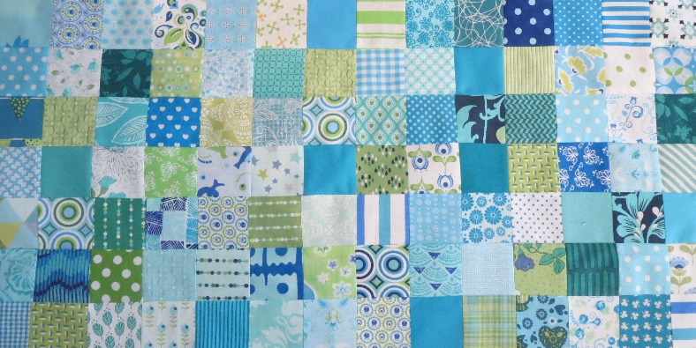
Groene Quilters
FEBRUARY 2023 Block 3 Orange Peel. Block is 10.5 by 10.5 inches including a 1/4 inch seam allowance.

What do you need:
- Fabric for 4 leaves And 2 x 4 squares. You need about 9 by 8 inches per block with leave.
- Rotary cutter, mat, scissors, frixionpen (or other kind of pen) and a glue pen.
- Needle and thread, pins.

The classic way with pins.
Choose the colors you want to use. You can choose to use the same fabric for the leaves and 2 different colors for the blocks. There are more variations possible. Place the template of the sheet on the back of the fabric, use a frixion pen or pencil to draw the template on the fabric. Cut out. Do this also with the template of the blocks. If you sew by hand, it is useful to mark the 1/4 inch on the fabric. With the sewing machine, that's not necessary if you're using a 1/4 inch foot or have a 1/4 inch setting.
The most convenient thing is to make a fold in the leaf. First the middle and then the 2 times quarter. You can also do that with the square. Then you start pinning from the middle. Place the middle folds on top of each other and pin, the quarter folds and pin. And then continue pinning proportionally. Now you can sew the parts. See the tutorials 1 and 2 below.

https://www.youtube.com/watch?v=YikGnjJMEVc
https://www.youtube.com/watch?v=mWafR2BRU3A
The classic way with the glue pen.
You can also opt for the glue technique. Instead of a lot of pins, use a glue pen. The following video shows you how to do this. I tried it myself and it has my preference on pins. They always get stuck in my fingers!

https://youtu.be/bMKinc43Lqk
Applique.
Please note! If you choose applique, you have to cut the leaf a 1/4 inch smaller. You then have the choice to iron or fold (needleturn applique) the seams inwards and sew it on the fabric by hand
There are more ways, like using freezer paper etc. You can also opt for return applique. Then you use fusible interfacing. In the tutorials below you see how to use that.

https://www.youtube.com/watch?v=ewCuKh-e6wo
https://www.youtube.com/watch?v=5tyAig7XupI
Appliquering with double fusible interface, is also called raw edge appliquer. You use two sides fusible interface. This is by far my favorite.

https://www.youtube.com/watch?v=WVSFT7kedB4

