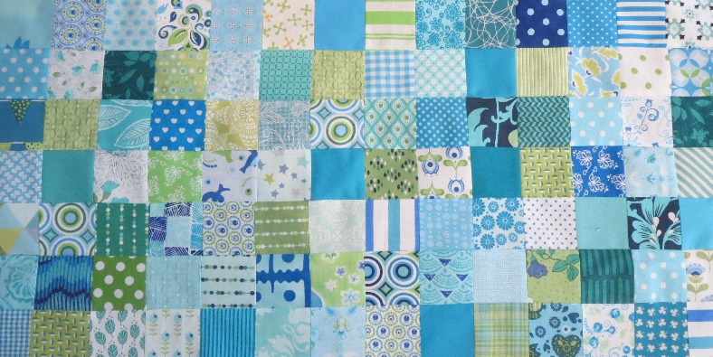
BOM 2023
DECEMBER / JANUARY 2023
This is the first in the series of 12 blocks. The quilt is about 1.40 by 2.00 meters. Of course, you can adjust everything to your own liking. You can hand-quilt everything, but for the most part also work with the sewing machine.

Block 1 Dresden Plate.
Block is 10.5 by 10.5 inches, this includes a surcharge of a 1/4 inch seam allowance.

What do you need:
• 1 piece of 10.5 by 10.5 inch fabric.
• 12 patches in 2 or more different colours. Size 2.5 inches by 5.5 inches.
• Mould A or B
• Cutting mat, cutting knife, pencil, pen
• Scissors
• Needle and thread

Cut out template A (you have a spare) and cut 12 pieces of fabric in the shape of the template. I put the template on the back of the fabric and use a frixtionpen or a pencil. Because I use a sewing machine I have 1/4 inch foot. When I don't use the machine, I also cut out the 1/4 inch seam, so I can use the template to draw that on the fabric to. I'm sure there are easier ways of doing it (You can always tell us!). If you are going to make more Dresden plates, it is useful to make a template from paterno plate.
​Cut the leaves from the fabric. Sew the 12 leaves together, iron flat.
Tip: Per template you need 2.5 inches by 5 inches, but if you place two opposite against each other on the fabric, you have less waste.

There is also another way.
Cut out template B. Cut the fabrics to size. Here, too, you lose less fabric.
What you do first is, at the top (the widest piece) with the back in the middle against each other and sew this together at a 1/4 inch. If you have done this, then you take the right side out again and iron it flat. You do this with all 12 leaves and then put them together. Now you no longer have to fold the points inwards and you can immediately sew the Dresden plate on the fabric. You can place a circle in the middle if you like that.

The Missouri Star shows how to do this. Copy this link into your google if it doesn't work!
https://youtu.be/lcy_p4pryE4

