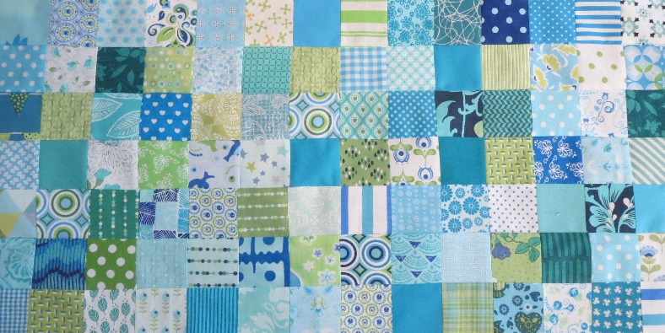
Groene Quilters
JUNE 2023
Block 7 Flower applique block. Block is 10.5 by 10.5 inches including 1/4-inch seam allowance. What do you need?
- Background fabric and various fabrics for the flower.
- The templates for the block.
- Cutting knife, ruler, scissors Needle and thread, pins.
- Fusible webbing if you make it as a raw edge applique.

Traditional applique or needle turn applique
Decide which colors and fabrics you want to use for which form. You can cut out the templates and then use the template to draw the outline on the fabric, but then you already have your 1.4-inch seam allowance. Or you can trace with the use of a light box, but you can also use copy paper (for fabric). Fold the seam allowance inwards, with round shapes it is useful to make cuts in the edge of the seam allowance. Cut the background to size of 10.5 by 10.5 inches. Fold in half from the corners so you can more easily determine the center. You can also use a friction pen and light box to place the design under the background fabric and trace it, so you know exactly where everything form has to be placed.
Sew the shape on the background fabric with very small stitches. There are other ways in which glue is also used. There are plenty of videos on YouTube.

https://www.youtube.com/watch?v=khZnGx9U5Y4

Raw edge applique.
If you want the fast way to applique, you can use fusible web. Use the templates without the seam allowance. The fabrics are then sewn onto the fabric with a small zigzag or blanket stitch.

https://www.youtube.com/watch?v=G3-2M5II9sE
https://www.youtube.com/watch?v=GoAclMt-L8Y

Turned edge applique
For bigger pieces this could also be an option.
https://www.youtube.com/watch?v=vOYgE6QI7ww

