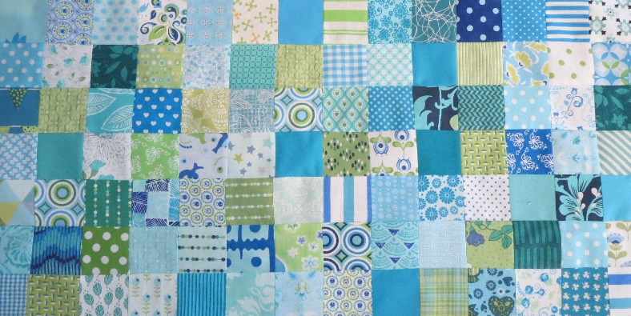
Groene Quilters
MAI 2023
Blok 6 Antiq Mosiac block. Block is 10.5 by 10.5 inches including 1/4 inch seam allowance.
What do you need need:
- Background fabric and various fabrics.
- The templates for the block.
- Ruler or scissors.
- Needle, thread and pins.
There are 3 pdfs with template for this block. You can choose between the traditional way ( 1 pdf) or fpp (2 pdf’s). It looks hard, but it's a fun block to make. You can choose to work with two colors or more. They are all half square triangles. You can start from the middle, but it's easier if you make them in 4 rows and then put them together.

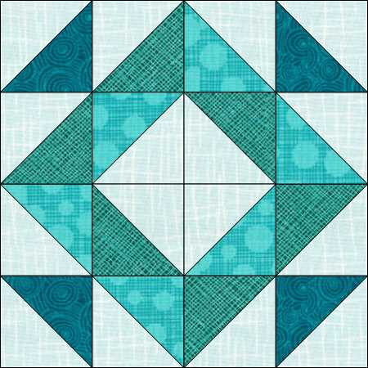

Watch Karen Brown from Just Get it Done Quilt. She shows you 10 methods to make half square triangles HST’s. On YouTube you will find a lot more!

https://www.youtube.com/watch?v=kB4gzrRlLsM

